Community Membership Application and Approval
Review

Mobile UI
No. | Screenshot | Review
1. | 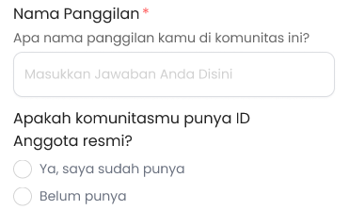 | - Perbarui urutan:  - Id keanggotaan  - Nama panggilan
2. | 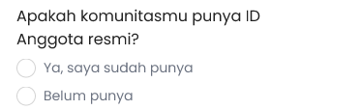 | - Product requirement:  - Allow community managers to activate manual Member ID for their community.  - When Member ID is activated:  - Existing members (real) can enter the Member ID already created by the community when registering to communities in Kolavo. For new members who do not yet have a Member ID, the community manager can assign one before accepting them.  - System prevents duplicate Member ID within the same community.  - Automatic Member ID generation is out of scope for V1.  - Design requirement:  - Question Membership ID  - Label: Nomor Keanggotaan  - Description/question: Isi nomor keanggotaan jika ada  - Seperti ini ya, pakai field sama seperti pertanyaan lain.  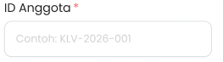
3 | 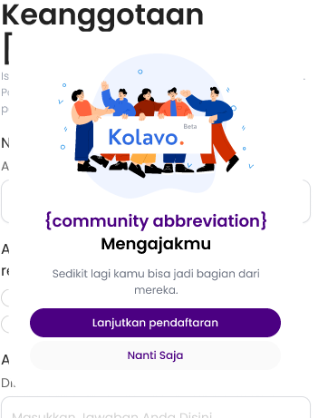 | - Background dark sedikit transparan
4 | 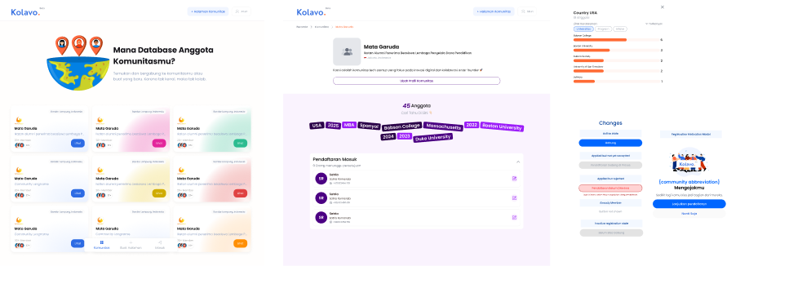 | - Approval untuk admin di mobile blm ada  - Udah ditambah

PC UI
No. | Screenshot | Review
1 | 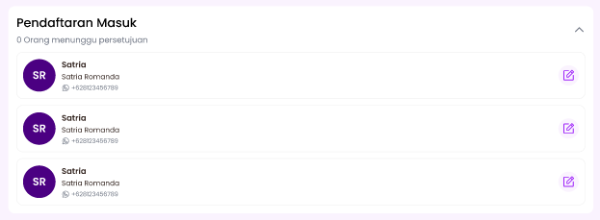 | - By default di minimize saja
2 |  | - Urutan untuk admin:  - Pendaftaran masuk  - Member distribution

